Individual Transition Plan
(ITP BLOCK 1)

Full Name: Anticipated Separation Date:

Rank: Unit:

Date attended Pre-separation Counseling: (attach copy of DD Form 2648 / 2648-1)

List your top 3 Military Occupation Code(s) and Title(s):

TRANSITION PLANNING OVERVIEW

The key to a successful transition is planning, which requires a carefully thought out Individual Transition Plan (ITP). The ITP provides a framework to achieve realistic career goals based upon an assessment of your personal and family needs as well as your unique skills, knowledge, experience, interests and abilities. You create and maintain your ITP with assistance from your Transition Counselor using the following template. The ITP coincides with the Transition GPS (Goals, Plans, Success) outcome-based curriculum and provides a means to discover and explore your skills and interests which may lead to potential post-transition career paths. The ITP helps you identify critical activities associated with your transition and your Transition Counselor will assist you through the process of organizing your transition into manageable tasks. The ITP also helps you to establish a timeline for completing all required activities prior to separation – it is a living document and can be modified at any time. The ITP is the road map for attaining your employment, education, technical training, and entrepreneurial objectives and can help you make a successful transition to civilian life. To develop a successful ITP you must consider the following critical elements in your planning process:
I. Identify Post-transition Personal/Family  Requirements (ITP Block 1)  - Taking Care of Individual/Family Needs  - Assessing Benefits and Entitlements  - Getting Financially Ready  III. Determine Post-transition Career Path  - Finding a New Job (ITP Block 2)  - Continuing Your Education (ITP Block 3)  - Pursuing Technical Training (ITP Block 4)  - Starting a Business (ITP Block 5) | II. Evaluate Military and Civilian Experience  and Training (ITP Block 1)  - Documenting Job Related Training  - Verifying Eligibility for Licensure, Certification  IV. Create a Transition Timeline (ITP Block 6)  - Identifying Planning Milestones  - Synchronizing Specific Activities

CAREER READINESS STANDARDS
Prior to completing your Individual Transition Plan (ITP), it is important to note that there are Career Readiness Standards you will be expected to meet. You will be required to provide documentation of meeting the following readiness standards to your Transition Counselor and Command representative prior to separation. These standards are designed to increase your ability to successfully overcome any challenges you may face in pursuit of your chosen career path. Some Career Readiness Standards apply to all career paths (Employment, Education, Technical Training and Entrepreneurship) while others only apply to a specific career path.

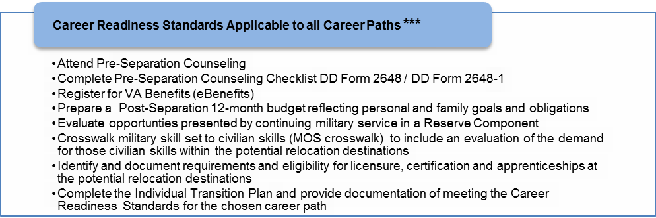
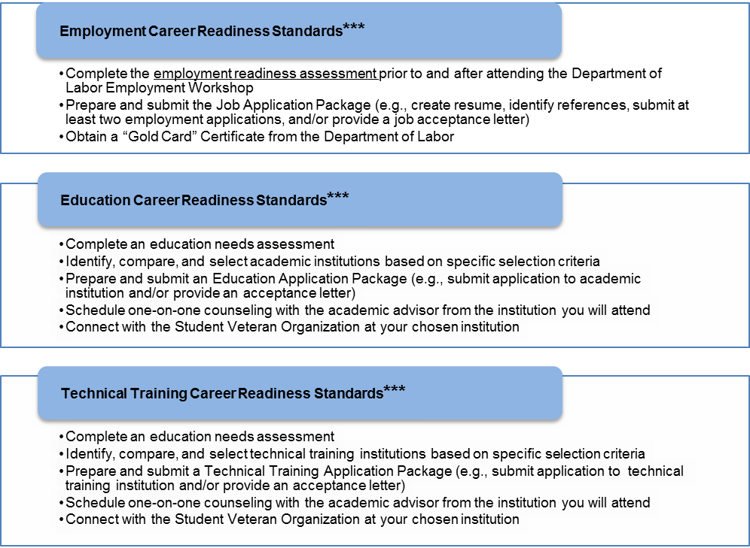
*** Career Readiness Standards are noted by 3 asterisks throughout the Individual Transition Plan
PERSONAL ASSESSMENT
Section I. Identify Post-transition Personal/Family Requirements
- Taking Care of Individual/Family Member Needs

- Identify individual/family needs such as medical care, expenses, and location of potential providers.
Notes:

- Identify extenuating individual/family circumstances (e.g. need to provide care for elderly parents, family business, exceptional family member needs, etc.).
Notes:

- Assess impact of individual/family requirements on relocation options (e.g. quality of local schools, availability of medical care, spouse employment opportunities, etc.).
Notes:

- Evaluate your immediate post-transition housing requirements. Determine how much living space you will require to safely house yourself, dependents, and personal items. Consider whether you may need to make more than one move or need to utilize temporary storage. Contact the housing referral office to identify local and remote housing options. The installation transportation office can provide detailed information about planning the movement and storage of your household goods. Visit the VA website: http://www.benefits.va.gov/homeloans/ to get information on the VA home loan program.
Notes:

- Consider your post-transition transportation requirements. Determine if you have adequate reliable personal transportation to take you to and from your place of employment or school. Evaluate your commuting options and whether you need to purchase another vehicle(s) for your spouse and/or dependents. Identify your post-transition transportation expenses to include: purchase costs, vehicle registration, insurance, maintenance, fuel, etc. If you are disabled, determine if you are eligible for assistance in purchasing a vehicle and/or automotive adaptive equipment by visiting http://www.warms.vba.va.gov/regs/38CFR/BOOKB/PART3/S3_808.DOC
Notes:

- What person or persons do you go to for advice, personal counsel and/or mentoring when facing a difficult challenge or decision? Will you still have access to those persons after you separate from active duty? Consider what steps you need to take now to maintain contact.
Notes:

- With whom do you spend your leisure time now? Who is a part of your social network? How did you meet them? Determine the steps you need to take to continue these relationships or establish this type of support in the community where you will live post-separation.
Notes:

- Assessing Benefits and Entitlements

- *** Evaluate the benefits (e.g. additional income, promotions, leadership and professional development opportunities, travel) associated with continuing your military service in either the Reserves or National Guard (if applicable). Consider the financial impact of continued entitlements such as medical and dental coverage, life insurance, military exchange, commissary, club privileges, recreational and athletic facilities. Contact the installation/ local recruiter to schedule an informational counseling session and identify potential units/positions.
Notes:

Recruiter counseling date: Financial impact:

- *** Register for your VA Benefits and assess their impact on future financial obligations: www.ebenefits.va.gov
Notes:

Date applied for eBenefits:

- Getting Financially Ready

- Identify anticipated financial obligations such as dependent college savings plan, retirement savings plan, utility security deposits, and additional commuting/transportation expenses (e.g., additional car payment, fuel, maintenance, insurance).
Notes:

- List required new civilian workforce wardrobe items and estimate expenses.
Notes:

- Develop and attach a plan to reduce/eliminate current debt: https://powerpay.org/
Notes:

Date you reviewed your free credit report (http://www.annualcreditreport.com/):

- *** Develop a 12-month budget based on your current financial obligations (e.g., living expenses and indebtedness) as well as anticipated post-transition expenses. Determine if your expected post-transition income will adequately address anticipated financial obligations (e.g. housing, medical, food, insurance, transportation, costs of establishing a home, utility security deposits, etc.). Use the TurboTAP Financial Planning Worksheet for Career Transition at: http://www.turbotap.org/export/sites/default/transition/resources/PDF/financial_planning_worksheet_fillable.pdf

- Attach a copy of your TurboTAP Financial Planning Worksheet for Career Transition and bring a copy to the Core Curriculum TAP workshop.

- Estimate your annual salary/income requirements:

Section II. Evaluate Military and Civilian Experience and Training
- Documenting Job Related Training

- Check all that apply:
High School Graduate/GED Training Certificates/ Licenses Baccalaureate Degree
Vocational School Apprenticeship Post Graduate Studies
Relevant Training Some College Master's Degree
Technical Training Associates Degree Doctorate

- Gather documentation of your civilian and military experience/training (e.g., certifications, diplomas, transcripts, licenses, etc.) and list them below. This may require research on your behalf to contact former technical training and academic institutions to identify their specific procedures and any applicable fees for providing this service.

- •

- •

- •

- *** Verify your military experience and training at: https://www.dmdc.osd.mil/appj/vmet/index.jsp. Assistance is available by meeting with an Education Counselor and instruction is available by attending the Transition GPS Core Curriculum training. Review the list of schools documented on the VMET site. If necessary, gather documentation and list below all military professional development schools you completed that are missing from the VMET site:

- •

- •

- Calculate American Council on Education (ACE) credits earned for military training (if applicable): http://www.acenet.edu/Content/NavigationMenu/ProgramsServices/MilitaryPrograms/index.htm

Number of ACE credits earned:

- Verify Eligibility for Licensure and Credentialing.

- *** Crosswalk your military skill set to the corresponding civilian skills (MOC Crosswalk) at: www.online.onetcenter.org/crosswalk. Assistance is also available by meeting with an Education Counselor and instruction is available by attending the Transition GPS Core Curriculum.
Notes:

- *** Identify and document transferable credits earned through your military experience and training and verify your eligibility for licensure, certification and apprenticeship programs:
Department of Labor Workforce Credentials Information Resource Center | www.careeronestop.org/CREDENTIALING/CredentialingHome.asp
U.S. Army Credentialing Opportunities On-Line (COOL) | https://www.cool.army.mil
Army/American Council on Education Registry Transcript System (AARTS) | http://aarts.army.mil/
United Services Military Apprenticeship Program (USMAP) | https://usmap.cnet.navy.mil/usmapss/static/usmap.jsp
Defense Activity for Non-Traditional Education Support (DANTES) | www.dantes.doded.mil/dantes_web/danteshome.asp
Navy Credentialing Opportunities On-Line (COOL) | https://www.cool.navy.mil
Sailor/Marine American Council on Education Registry Transcript (SMART) | https://smart.navy.mil/smart/signIn.do
Community College of Air Force (CCAF) | http://www.au.af.mil/au/ccaf/index.asp
Air Force Credentialing and Education Research Tool (CERT) | https://augateway.maxwell.af.mil/ccaf/certifications/programs/

- Identify career field(s) you are qualified to enter.

- Conduct personal research to explore and evaluate potential career field options.
Note: Any Guard or Reserve member facing employment difficulty prior to or after an active duty tour can contact Employer Support of the Guard and Reserve (ESGR.org) to learn their legal rights. ESGR will work to resolve conflicts or misunderstandings between the member and their employer.
DoD and VA Employment Search Tools & Job Listings | https://h2h.jobs  http://www.vetsuccess.gov/jobs
Employment Hub | www.turboTAP.org/portal/transition/resources/Employment_Hub
State Job Boards | www.careeronestop.org/jobsearch/cos_jobsites.aspx
Public and Community Service Opportunities | http://www.turbotap.org/portal/transition/lifestyles/Employment/Public_and_Community_Service_PACS_Registry_Program
Department of Labor | http://mynextmove.dol.gov/
Teaching Opportunities/Troops to Teachers | www.proudtoserveagain.com
Federal Employment Opportunities | http://www.usajobs.gov/  www.go-defense.com
Veterans Preference in Federal Employment | http://www.opm.gov/staffingPortal/Vetguide.asp  http://www.fedshirevets.gov/
Office of Personnel Management (OPM) Special Hiring Authorities | http://www.opm.gov/hr_practitioners/lawsregulations/appointingauthorities/index.asp
Hiring Preference in  Non-Appropriated Funds (NAF) Jobs | http://www.turbotap.org/portal/transition/lifestyles/Employment/Federal_Jobs_Through_the_Non-Appropriated_Fund_and_the_Veterans_Readjustment_Act
State Employment Agencies | www.careeronestop.org/jobsearch/cos_jobsites.aspx

- Refine your research to identify desired industries, careers, jobs and salaries. Consider jobs in the public and private sectors. Identify any prerequisites you would have to complete (e.g., education, training, certification, licensure, security clearance) before being fully qualified to seek employment in a chosen career field. Assistance is also available by meeting with a VA Career Counselor and instruction is available by attending Transition GPS.
Notes:

- Now that you identified potential careers, evaluate your ease to relocate and find new employment. Find where opportunities exist by researching employment websites such as http://www.usajobs.gov/, and the Veterans Job Bank: https://www.nationalresourcedirectory.gov/home/veterans_job_bank.
Notes:

- Now that you know where potential jobs exist, research those locations to determine if they meet your personal/family requirements. Explore state, city and county websites to evaluate demographics, school ratings, tax rates, cost of living, availability of housing, home prices, etc. Assistance is also available through your Transition Counselor and installation relocation assistance office and through the U.S. Census Bureau: http://factfinder2.census.gov/faces/nav/jsf/pages/index.xhtml.
Notes:

Section III. Determine Post-transition Career Path
- Designate the career field you wish to pursue based on your personal, family and financial obligations and desires.
Desired Career Field:

Desired Relocation Destination:

- Designate your transition career path.

- Select the transition career path you wish to pursue. Use the statements below each path to help you determine the appropriate transition career path.

  - Employment (refer to ITP Block 2, Employment, Sec. IV; and Block 6, Milestones, Sec. VIII)
- I am qualified to seek immediate employment in my desired career field or I plan to explore future employment opportunities.

  - Education (refer to ITP Block 3, Education, Sec. V; and Block 6, Milestones, Sec. VIII)
- I require additional education in my desired career field.

  - Technical Training (refer to ITP Block 4, Technical Training, Sec. VI; and Block 6, Milestones, Sec. VIII)
- I require additional technical training in my desired career field.

  - Entrepreneurship (refer to ITP Block 5, Entrepreneurship, Sec. VII; and Block 6, Milestones, Sec. VIII)
- I desire to start my own business.

TRANSITION MILESTONES (ITP BLOCK 6)

Section VIII. Use this template to develop your individual transition timeline. This example is not intended to be an all-inclusive list of actions applicable to your transition. However, the items marked as "Required" are mandatory planning activities and must be completed to achieve the required Career Readiness Standards applicable to your chosen career path. Additional room is provided to allow you to tailor this timetable to meet your specific requirements.
Timeline to Separation | Required | Milestone | Scheduled Date | Completion Date
24 months – 18 months | R | - Attend Pre-Separation Counseling and complete Pre-Separation Counseling Checklist
 | R | - Prepare Individual Transition Plan (ITP)
 |  | - Evaluate future personal and family housing, transportation and financial requirements
 | R | - Crosswalk military skill set to civilian skills
 | R | - Identify and document requirements & eligibility for licensure, certification and apprenticeships
 | R | - Complete the Employment Readiness Assessment tool as directed during Pre-separation Counseling
 |  | - Visit the Education Center to assess your job skills and interests. Sign up for college entrance exams, training opportunities, license programs, college courses, or certification exams
 | R | - Attend the Employment Workshop
 | R | - Complete the educational needs assessment (only required if attending Transition GPS Education or Technical Training tracks)
 | R | - Identify, compare, and select academic institutions based on specific selection criteria
 |  | - Attend a counseling session with a Small Business Administration Advisor
 |  | - Consider the possibility and impact of transferring Post 9/11 GI-Bill benefits to dependents
18 months – 12 months |  | - Begin establishing a professional network
 | R | - Prepare and submit an Education/Technical Training Application or provide an enrollment acceptance letter
 |  | - Create a business development plan
 |  | - Update personal legal documents
 |  | - Identify anticipated financial requirements and sources of capital for your business
 |  | - Identify and document chronic medical/dental problems and seek treatment for yourself and your family
 |  | - Research potential destinations for your post-separation relocation; evaluate employment opportunities for your chosen career
 |  | - Schedule and attend individual counseling sessions with Transition Counselor
 | R | - Develop a 12-month post-transition budget
 | R | - Develop a resume(s)
 |  | - Join a professional organization(s)
12 months – 6 months | R | - Register for VA Benefits on eBenefits portal
 |  | - Apply for VA Benefits
 | R | - Complete one-on-one counseling with an academic advisor at educational/training institute
 | R | - Visit Guard or Reserve Recruiting Office ( if applicable)
 |  | - Receive post-military service employment restriction counseling
 |  | - Review and make a copy of your personnel and medical records
 | R | - Submit two Job Application Packets or present an employment acceptance letter
 |  | - Learn Federal job search process and begin posting resumes (as applicable)
 |  | - Conduct informational interviews
 |  | - Research Survivor Benefit Plan options
 |  | - Research and compare VGLI to other insurance
180 days – 30 days |  | - Schedule a separation or retirement physical
 | R | - Obtain a “Gold Card” Certificate for preferred services at the Department of Labor Career One-Stop Centers
 |  | - Start assembling a wardrobe for next job
 |  | - Review DD form 214 worksheet
 |  | - Visit Relocation Assistance Program office
 |  | - Schedule a visit to the area where you plan to live
 | R | - Connect with the campus Student Veteran Organization if available or contact the local VA representative to identify local Veteran resources
 |  | - Arrange for government housing inspection
 |  | - Make contact with Workforce Development Office
 |  | - Continue to send resumes and begin interviewing
 |  | - Decide on a Continued Healthcare program

Transition Counselor is a term used by the Army & Air Force; Advisor (Marine Corps); Command Career Counselor (Navy); State Transition Assistance Advisor (National Guard); Transition & Relocation Manager (Coast Guard).

